Lead Pipes in Providence, Rhode Island: Issue Explanation Document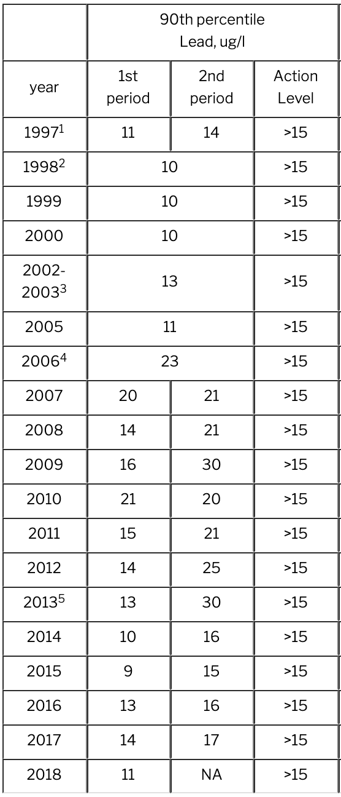

### **Section 0: History of Lead Pipes in Providence**

Since 2007, water tests conducted biannually around the city of Providence have found levels of lead which routinely exceed Environmental Protection Agency (EPA) standards.[1] As of 2018, Providence Water tests still indicate high levels of lead in drinking water in buildings and homes throughout the city. According to the the website of the local water utility Providence Water, “In the second half of 2018, Providence Water's 90th percentile level was 22 parts per billion (ppb), which is above the lead action limit of 15 ppb.”[2] As an older city, it is not surprising that Providence struggles with this problem. Due to the abundant supply of lead and lack of awareness on its health effects, lead was routinely used for plumbing in buildings built prior to World War II. While the city works each year to replace more and more lead pipes on the public side of the service lines, it cannot directly eliminate lead pipes that may be found on the private side of the service line in people’s homes. The information in this document covers the nature of the lead problem in Providence, from the health and social effects of lead in general, to the actions currently being taken by Providence Water to mitigate lead exposure throughout the city. 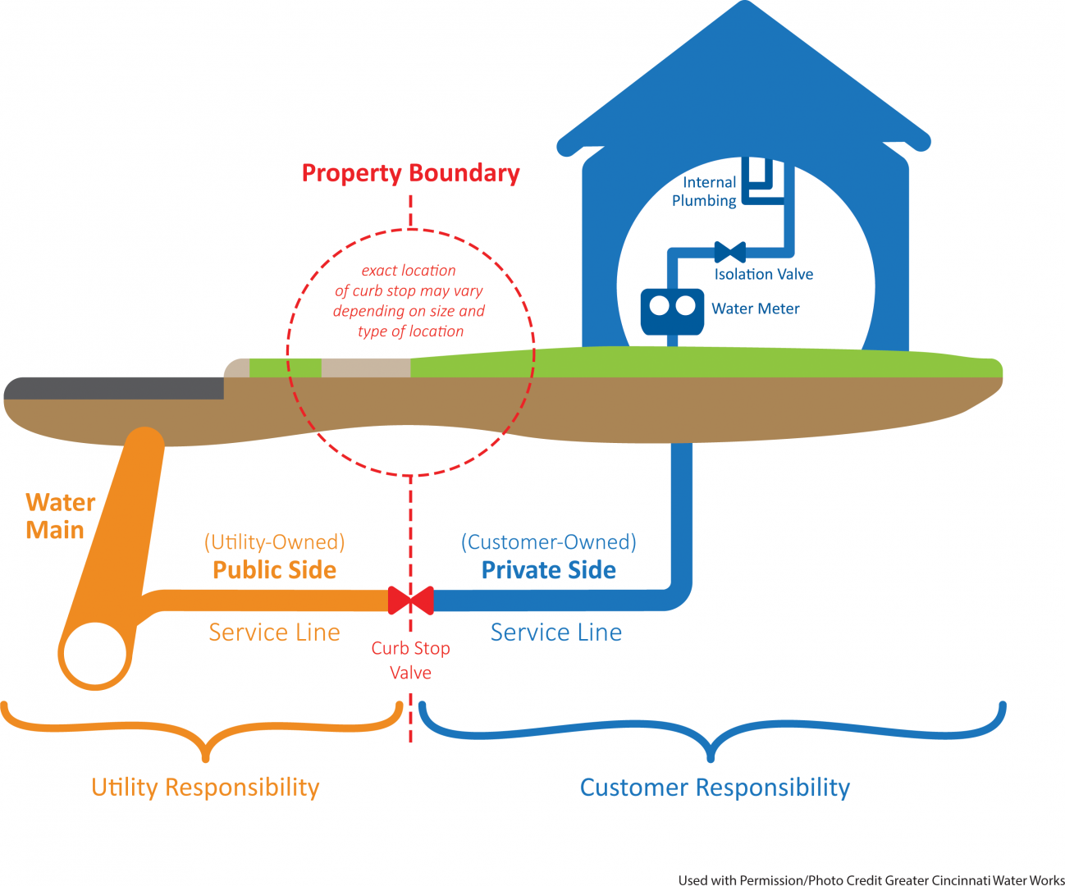

There are some key concepts that will be referenced throughout the rest of the document that will be defined here for clarity’s sake.

What is most important to understand is the distinction between private and public water lines. Water for a given street travels down a large central water main under the road surface, as shown in the diagram. Each house is served by a branch line, or service line, which has divided ownership as shown. Utilities are responsible for the public service line, and must maintain it. One example of this is the Water Main Rehabilitation Program, as will be explained later. The utility has limited rights and responsibilities, however, over private side piping. This explains how someone could test their water and find dangerous lead levels, while utilities could test their portion of the same piping yet find acceptable ones. This bifurcated ownership structure is important to keep in mind going forward.

### **Section 1: Health and Social Effects of Lead**

Lead is a poisonous metal that is harmful, particularly for children and pregnant women. Exposure to lead while pregnant is known to have adverse effects for infant and maternal health, especially relating to fertility, hypertension, and infant neurodevelopment.[3] Lead accumulates in the bones and is released through the blood during pregnancy, impacting the fetus during development.[4] After birth, infants are still at high risk for lead exposure, which can further stunt their development. Because infants have reduced maturity of “the blood-brain barrier, increased gastrointestinal absorption, and hand-to-mouth behaviors,” they are more likely to be victims of lead accumulation in their bodies, which has been found to affect the child’s neurodevelopment even into their 20’s.[5] In rare cases, ingestion of lead in children can cause seizures, comas, and even death. Lead has also been proven to impact a child’s mental, speech and language development.[6]

Due to the age of many of the pipes and houses in Rhode Island, lead is still present in many neighborhoods throughout Providence. Many houses built before 1978 contain lead based paint, which, in addition to lead in drinking water, poses a serious public health concern for policymakers and citizens alike. While all the ways that lead exposure specifically affects neurodevelopment have yet to be conclusively determined, a large consensus of public health professionals agree that lead is incredibly harmful to human health. As such, since 1991, as part of the Lead and Copper Rule, the Environmental Protection Agency has set action levels for lead in public drinking water systems at 15 parts per billion, at which point action must be taken to replace the service line or source of contaminant.[7] Meanwhile, the Center for Disease Control’s current lead exposure guidelines stipulate that no amount of lead exposure is safe, but public health intervention is recommended when a child’s blood lead level exceeds 5 micrograms of lead per deciliter of blood.[8]

Currently, lead-based paint accounts for about 70% of childhood lead exposure, yet lead-contaminated water can also play a significant role in a child’s lead exposure. There are a variety of benefits to lead hazard control and abatement, which will be summarized below.

**Social and Economic Benefits of Lead Abatement**

Economic

A 2009 study estimated the economic benefits and cost-savings that would be generated from lead paint hazard control. She concluded that “each dollar invested in lead paint hazard control results in a return of $17–$221,” a net savings of $189 to 269 billion.”[9] Though we know that lead-contaminated water is not as pervasive as lead-based paint and thus the economic benefits may not be quite as large, it is clear that there are net economic benefits to reducing lead exposure in general. The author argues these cost savings come from a reduction in healthcare-related needs, higher lifetime earnings and increased tax revenues from these earnings, a reduction in the need for special education, and a reduction in crime rates.

Lead’s Effects on Education and Crime

Beginning in the late 1990’s, researchers began investigating a startling correlation between lead exposure rates and crime trends. This body of research and what it attempts to investigate is best summarized by what many call the “lead-crime hypothesis.” It argues that lead exposure at young ages can leave children with academic and social disorders, like ADHD and troubles with impulse control, which causes them to commit higher rates of crime as adults.[10]

Many prominent studies have investigated the negative impact of lead exposure on educational achievement. In particular, one study done in the Chicago Public Schools, which controlled for other confounding factors like birth weight, found that 13% of reading failure and 14.8% of math failure can be attributed to exposure to blood lead concentrations of 5 to 9 vs. 0 to 4 μg/dL in Chicago school children.”[11]As many researchers also argue, lower academic achievement rates are also highly correlated with high incidence of crime.

The most compelling study that establishes a causal link between lead and crime was done in 2016 by Feigenbaum and Muller. It investigated the trends in crime in communities in the 1920’s century with and without lead pipes by exploiting natural randomization inherent to the fact that lead only seeps into water when the water is acidic. In other words, only towns with lead pipes and acidic water were actually exposed to lead. Capitalizing on this “natural experiment,” the researchers were able to draw out a causal relationship between lead and crime. In particular, they found that lead exposure “considerably increased city-level homicide rates.”[12] These findings have been corroborated by similar studies in recent years. As such, one study concluded that simply investing in lead paint hazard control would lead to cost savings of 1.7 billion from its relationship to direct crime.[13]

The powerful effect that lead exposure can have on the health and well-being of communities clearly extends well beyond personal health. It is clear lead exposure can have far-reaching effects on the safety of communities, making it a highly relevant public policy concern.

### **Section 3: Household Lead Response Options (Gisela)**

**Lead Testing Options**

EPA-approved home lead test kits recognized after September 1, 2010 must meet both the negative and positive response criteria. The negative response criteria is met when the test kit has a 5% false negative rate and the positive response criteria is met when the test kit has a 10% false positive rate. [14] The regulated level for lead in paint is 1.0 mg/cm2 or 0.5% by weight.

However, the EPA does not set a regulated level for lead in drinking water due to its toxicity even at low exposure level. Drinking water can make up 20% or more of a person’s total exposure to lead. Infants who consume formula can receive 40-60% of their exposure to lead from contaminated water. The Centers for Disease Control and Prevention (CDC) recommends that public health actions be initiated when the level of lead in a child’s blood is 5 micrograms per deciliter (µg/dL) or more.[15]

In Providence, individuals can pick up free testing kits from Providence Water to test for lead in their drinking water. “Lead sample kits can be picked up during normal business hours, Monday-Friday between 8:30-4:30 pm at 125 Dupont Drive or call Providence water at 401 521-6303. ”[16]

**Organizations that Provide Testing Services**

|  |  |  |  |  |
| --- | --- | --- | --- | --- |
| **Company** | **Method** | **Cost** | **Advantages** | **Cons** |
| SimpleWater (EPA approved) | **Essential City Water Lab Testing:** They send sampling vials which are mailed to the lab | $ 129 | * Tests for the most common contaminants * Recommends treatment options * High reliability | * Expensive * Takes a few days |
| Home Depot, Lowes, Ace, First Alert, WaterSafe, Abotex, 3M™ LeadCheck™ | **Instant Home Test Kit:**   1. Collect a sample after water has been stagnant for 6 hours 2. Place the test strips into the sample 3. Wait for the time frame detailed in the package(usually 10 minutes) | $ 12-$ 30 | * Results within minutes * Very affordable | * It does not tell parts per billion and might return negative when in fact there is some lead in the water * Prone to error |
| Water Filtration Companies: EcoWater, RainSoft | 1. Contact the company and schedule a time for them to come and test the water | Free | * For free | * They will advertise products to address the issue |
| Community Action Partnership of Providence | 1. Contact a LEAD Program Resident Educator to do a free inspection of your home for all possible lead contaminants 2. Acquire free prevention kits 3. Learn about financing and other resources for lead pipe replacement | Free | * Free * Beyond inspection, prevention kits and helpful information is provided | * Eligibility is limited to people with children under 6 years old or people with homes built before 1978 |

**Lead Pipe Identification Procedure**

If someone wants to identify whether or not there are lead pipes inside their home or leading to it, they can follow the following steps:[17]

1. Take a look at pipes inside your home (such as the ones going to the kitchen sink or shower) and if they are not painted and they contain lead they should have a grey color and should be soft.
2. Scrape the surface with a coin and you should see shiny silver metal and if the pipe is made of lead it will make a dull sound. You could also try and attach a magnet to it and if it does not then the pipes are lead.  
     
   As a guide other pipe materials have the following appearances:
   * Copper - bright or dull orange in colour, and hard
   * Iron - dark, very hard and may be rusty
   * Plastic - may be grey, blue or black[18]
3. To identify whether you have lead pipes supplying your property on the private side look up your address in the Providence Water website Service Line Search: <https://engineering.provwater.com/gis/servicelinesearch>. They also indicate whether the private side of the line could contain lead.

If you are still unsure whether your pipes are lead, or if you are unable to reach your pipes, a plumber could carry out these checks for you.

**Lead Mitigation Options**

**Replacing Lead Pipes**

If homeowners determine that the private pipes in their home are releasing high levels of lead into their drinking water, they may want to consider replacing the pipes in your home. The city of Providence has introduced a 3-year 0% interest loan on lead pipe replacement in an effort to make this process easier. This program allows for property owners to mitigate the financial burden of replacing their private service lines, which generally costs $2500 to $3000[19].

**Filtration System**

While you are in the process of replacing your pipes you might want to consider installing filters that will remove the lead from your water. It is recommended that you use a filter that has been approved by the NSF International or Water Quality Association as some filters might not be effective in removing the lead. The filter should remove 99% of the lead from the water. [20] Carbon Filters are the least expensive but effectiveness differs a lot. However all NSF-approved filters are effective for up to 150 parts per billion lead. “The activated carbon works like a magnet, and lead and other impurities in the water get chemically “stuck” to the filter.” [21]Reverse osmosis filters are the most effective, however they are very costly starting from $500.

**For Renters**

Rhode Island state law insists that landlords provide their tenants the right to “safe, healthy, and clean housing.”[22] Consequently, landlords are legally required to address all lead hazards on their property and to follow “lead-safe work practices” when undergoing residential repairs in housing built pre-1978. Landlords are legally obligated to provide a record of all past lead inspection reports and a proof of a Certificate of Conformance, should a potential or current tenant request either. Despite these regulations, 70% of rental properties in Rhode Island still pose some form of a lead hazard to their tenants.[23]

Tenants are responsible both for keeping the tenement clean at all times and notifying their landlord when they have concerns regarding the safety of the unit. It’s important to note that landlords are only legally bound to correct for “known” lead hazards. Tenants are often left responsible for making their landlord aware of potential lead hazards as they are the primary residents of the property.

PW distributes at-home lead-testing kits free of charge for tenants (see “Testing for Lead”). Other preventative measures include covering chipping or peeling paint with contact paper, duct tape, etc. until your landlord repairs it and ensuring that dirt that could contain lead from the garden is not tracked into the house.[24] Landlords should be notified of issues regarding paint and the quality of water immediately. It is important that tenants keep a close record of all tests/instances confirming the presence of a lead hazard within a home and communication about such hazards with their landlords.

If construction addressing a lead hazard in a tenant's home disturbs more than six square feet of wall space, landlords are required to hire a licensed “lead hazard control firm.” Landlords must provide proof of their repairman's license to their tenants. Work done by an unlicensed firm could exacerbate the problem and expose tenants to an even more significant lead hazard.[25]

Tenants with landlords that either fail to address demonstrated lead hazards or fail to hire licensed lead control firms should file a formal complaint through the Rhode Island Office of Housing and Community Development.[26] Tenants who seek legal assistance should consider Rhode Island Legal Services.[27] A tenant who believes their landlord is failing to address lead hazards as a form of discrimination based on that tenant’s identity should consider filing a report through the Rhode Island Commission for Human Rights.[28]

**Some Other Tips**

If replacing the lead pipes in the home is not a feasible option for someone, there are some measures they can take to ensure that their exposure to lead is minimized. If water in the building has not been used in a while, running the water for 3-5 minutes so that it has been flushed and is cold will reduce the levels of lead in the water. Additionally, hot water should never be used for consumption if someone is concerned there is lead in the water, especially when preparing baby formula. Using hot water can cause lead to remain in the formula, even after it has been flushed for a few minutes.[29] If you are certain that your water from the tap contains lead then it is advised to consume bottled water or have a filtration system for drinking water. Water should be used cold for any purposes and boiling it will not remove lead. [30]

### **Section 5: Lead Laws**

A variety of laws exist on the federal, state and local levels to reduce the prevalence of lead hazards. In order, the table below summarizes the details, from smallest to largest jurisdiction.

|  |  |
| --- | --- |
| **Law** | **Summary** |
| **Providence Municipal Code** | The 2018 version of the PMC references lead in the following contexts:   * Investments under the jurisdiction of the Board of Investment Commissioners and/or the Finance Director shall not knowingly be invested in any paint manufacturer subsequently held liable for lead poisoning in the state.[31] * The Department of Inspections and Standards shall issue an annual report on the city’s housing stock, including noting, among other things, environmental hazards such as lead paint.[32] * Utensils containing or plated with lead shall not be used in restaurants.[33] |
| **Lead and Copper Drinking Water Protection Act (2016)** | This Rhode Island law enacts the following authorizations of funds:   * Those available for grants to local governmental units and private water companies; * Those from federal capitalization grants to   + conduct baseline testing of drinking water supply systems of each local governmental unit responsible for the ownership or operation of water supply facilities, or privately organized water suppliers, that provide water to more than one municipality, and   + conduct testing of water supplies at all public schools serving preK-12 and all state licensed daycare facilities for compliance with all state and federal laws, rules, and regulations pertaining to lead and copper levels in drinking water supplies; * Orders the reporting of the department’s findings to the speaker of the house and the senate president by 4/30/2017, including a plan for ensuring compliance with all state and federal laws, rules, and regulations pertaining to lead and copper levels in drinking water supplies. [34] |
| **Lead Hazard Mitigation Act** | This Rhode Island law establishes that:   * Owners and landlords must obtain a Certificate of Conformance for each unit that must be kept current, as well as notify tenants of any potential lead hazards and respond to any tenant concerns.[35] * Landlords have a duty to mitigate lead hazards in their units within 30 days of notice from a tenant * Landlords may not refuse to rent to pregnant women or families with children in order to avoid that duty.[36] |
| **Occupational Health Lead Protection Act** | This Rhode Island law stipulates:   * The prohibition of the use of state funding for any project that involves the disturbance of lead-based paint or surface coating *unless* the contractor is in compliance with:   + OSHA’s lead regulations,   + the respiratory protection standard,   + the construction industry standard, and   + all environmental lead regulations promulgated by the departments of health and environmental management * That the contractor pay for all medical monitoring of employees**[37]** |
| **Lead Paint Removal Revolving Fund** | The following rules and regulations apply to this RI fund:   * This fund is to be within the treasury’s discretion for disbursement to the Rhode Island housing and mortgage finance corporation, following rules set forth by the Department of Health * Allocated funds are to be made available to individuals and non-profits for lead hazard reduction in residential units. * Loan repayments from this fund must be returned to the fund. * The Department of Health and the Corporation must take any action necessary to obtain federal assistance for lead hazard reduction[38] |
| **Duties of the Office of Private Well Water Contamination** | As they relate to lead, the RIGL states the following:   * It is within their jurisdiction to develop and promulgate any rules and regulations that are necessary to establish drinking water quality standards for private wells, which minimally shall:   + Require testing for lead of all new private wells prior to being placed into service as a source of drinking water, all private wells currently in service, or capable of being placed in service, as a source of drinking water, prior to sale of a property upon which they are located or serviced; * The Office shall establish and maintain a database showing known areas where there are contaminants of concern to public health and make these results available to the public through the website of the Department of Health.[39] |
| **Safe Drinking Lead and Copper Rule (1991)** | This Federal Rule does the following in relation to drinking water:   * Sets an action level of 15 ppb of lead in 1 L of first-draw water taken after the water has been standing in the pipes for at least 6 hours; * Establishes a *non-enforceable* maximum contaminant level goal (MCLG) of 0, the level of lead in drinking water at which no adverse health effects are likely to occur * Requires water utilities to monitor lead in drinking water from a sample of customer taps in homes with plumbing materials that contain lead and copper.   + If >10% of the samples collected from a water utility serving <50,000 residents exceed the lead action level, the utility must identify and install optimal corrosion control treatment.   + Utilities serving ≥50,000 residents are required to have optimal corrosion control treatment regardless of level of lead in drinking water.   + Any size water utility that exceed the action level must distribute public education materials on lead to customers and organizations that serve consumers with populations at high risk for adverse health effects from lead, including information about the health effects of lead, sources of lead, and steps persons can take to reduce their exposure to lead, until lead water levels are below the lead action level. * Requires that additional action be taken when a water utility with lead service lines and optimized corrosion control treatment still exceeds the action level in >10% of samples   + Utility companies are responsible for replacing the portion of the lead service lines that the utility company owns. They must offer to replace the section of line owned by the customer but is not required to bear the cost.   + If a customer does not replace their private pipes, the utility must notify residents 45 days in advance that they may experience a temporary increase in water lead levels as the public line is replaced and provide guidance on minimizing their exposure.   + After completion of partial replacement, the utility must collect a water sample within 72 hours to test for lead and notify the customer of the results.[40] |

**Disclosure Laws**

In addition to the laws detailed above, disclosure requirements describing what a property seller must disclose to potential buyers are also relevant. In 1996, it became a federal law that sellers disclose the presence of lead paint within their homes to prospective homebuyers. *A comparable law regarding lead pipes does not exists at the federal level.* According to the State of Rhode Island General Laws, a homeowner is required to disclose the following to a potential home buyer: year built, roof age and defects, structural conditions, termites or other pests, and others.[41] The statute makes no reference to the presence of lead pipes within a home nor the condition of those pipes. The law requires sellers of properties to provide testing histories of private water supply testing results, but not public supply testing results. Hence, testing results from homes served by water utilities do not have to be disclosed.

The disclosure of the existence of lead pipes in a home that is for sale is thus is entirely voluntary based on the current laws. Nevertheless, the statute lays out the process by which this could be changed. It notes that “The Rhode Island real estate commission has the right to amend the seller disclosure requirements by adding or deleting requirements when there is a determination that health, safety, or legal needs require a change.”

*This could be a potential avenue for action.* A review of Rhode Island’s disclosure laws by the Environmental Defense Fund indicates that *Rhode Island’s disclosure laws are incredibly poor.* The group rates lead pipe disclosure requirements for housing across states by the extent to which disclosure of lead pipes or related environmental hazards is required.[42] Rhode Island’s housing disclosure policies *received a D-grade from the EDF.*According to the report, Rhode Island has “mandatory disclosure of defects and deficiencies, but not specifically environmental hazards; voluntary disclosure of general environmental hazards.” Rhode Island’s rating places it within the bottom 12 states in terms of disclosure regulations.

### **Section 6: Current Responses**

**Fixing Public Lines**

Providence has struggled with evidence of lead-contaminated water caused by lead piping for at least the last decade. According to the Rhode Island Public Utilities Commission,[43] in 2006, for the first time, lead levels in sampled water exceeded the EPA’s Lead Action Level of 15 parts per billion. Lead levels have continued to exceed standards since then, although by varying degrees of significance in each year. It is important to note that studies, such as this one,[44] have found that there is no statistically significant effect on children’s blood lead levels when lead content in drinking water falls below this action level of 15 ppb. This means that we can certainly achieve measurable success from aggressively instituting a program that will bring lead contamination down below these levels.

Providence Water responded to the city’s poor lead levels by enacting a Lead Service Replacement program in 2007. After taking inventory of public lines in Providence and determining 25,600 to be lead piping, Providence Water enacted a program stipulating the replacement of 7% of lead service lines annually. As of 2010, according to Providence Water, 15,645 remaining public lead service lines needed to be replaced.

In 2010, after the EPA found that partial replacement could lead to increased lead particles in household water supply during the time of the repair,[45] the Department of Health and Human Services mandated that Providence Water discontinue its Lead Service Replacement Program. Since then, the mandate to replace 7% of lead service lines annually had been eliminated, and all lead pipe repair occurs as a part of the Water Main Rehabilitation Program.[46] In other words, while Providence Water used to have a program that mandated a specific level of responsibility to fix lead piping, with the elimination of this program, they no longer do.

The WMRP fixes the neediest segments of the public water lines, whether those needs are related to the existence of a lead service line, an issue with flow, or other water quality-related issues. Providence Water is responsible for both main lines and the branching segments of the line, which connect the public system to the privately-maintained pipes of each individual house, as shown in the diagram below. While it is known that of [Providence](https://www.provwater.com/sites/default/files/uploads/users/user10/Info%20About%20Lead%20in%20Drinking%20Water%20rev%2003.02.18_0.pdf) Water’s 76,500 service connections, 12,300 (16.07%) have a lead service from the utility, there is no unique program aimed at eliminating this problem. Lead-related repairs are rather conducted as a part of the larger water main replacement program.

This program is outlined in Providence Water’s 20-year Infrastructure Replacement Plan,[47] which currently runs from 2016 to 2035. It utilizes a ranking system that establishes certain issues as high priority. Water quality and condition are the highest priority items. Water quality confirmed issues “mainly originate through customer complaints because of discolored water.” Condition issues are determined as “known structural issues caused by deterioration of the pipe’s exterior… or interior.” On the flip side, lead services, defined as “main segments containing active lead service connections,” are currently listed as the lowest priority items for repair. (III 8-10) 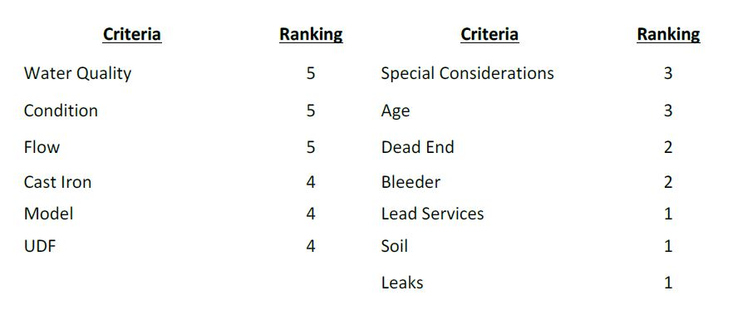

Moreover, the infrastructure plan allocates $500,000 a year, from 2016 to 2020, specifically for lead pipes service repair. This constitutes roughly 1.5%[48] of the expected budget for Providence Water infrastructure repairs for the 5 year period. (III 33-34) According to discussions with Providence Water, it would cost roughly $18-20 million to replace the remaining 12,700 public lead service lines.

If you consider only the dollars specifically allocated for lead pipe repair and the projected costs of repair, *complete elimination of public lead service lines would take another 40 years.* That being said, as part of the water main rehabilitation program, public service lines-- many of which could be lead-- are being replaced each year throughout the city for a variety of reasons, so this time estimate is likely a bit high.

In the fall of 2018, Rhode Island was awarded more than 21 million dollars from the EPA to support clean water projects across the state,[49] though it is unclear how much of this funding will be allocated to Providence and/or to lead pipe repair.

**Fixing Private Lines**

While replacing public service lines is an important aspect of achieving lead-free water in Providence, the other equally important component of this involves replacing private lines, something that Providence Water cannot do without homeowner and business owner involvement. If a home/business owner replaces the private section of their service line, Providence Water will replace the public section of the line at no cost.[50] Therefore, if a homeowner replaces the private side of their service line, they can guarantee that their entire service line is lead-free and eliminate lead-related risk resulting from the piping in front of their water meter. This implies that increasing the rate of private lead service line replacement will increase the rate of public replacements as well.

Furthermore, Providence Water provides direct assistance for home and business owners to replace their private lines in two key ways: 1) Providence Water will provide any individual with a no-cost estimate for the replacement[51], and 2) Providence Water offers individuals a 3-year interest-free loan on the $2500 to $3000 cost of replacement.[52]

The private repair loan fund was originally endowed with $1.25 million in funding. According to Providence Water, the Rhode Island Infrastructure Bank provided the initial $1 million for the program, which was a one-time, non-renewable allocation. Providence Water provides the other $250,000, which is designed to be replenished as individuals pay back their loans.

### **Section 7: Possible Interventions**

|  |  |  |  |
| --- | --- | --- | --- |
|  | **What** | **Why** | **How** |
| More Equitable Funding | Ensure WMRP treats neighborhoods in order of assessed need | Current ublic data does not reveal how this is done | Insert a specific mandate in PW guiding law |
| Prioritize Lead Replacement | Upgrade lead from 5 to 1 in repair importance. | Lead is a first order public health concern | Pressure PW to change internal metrics |
| Increase Funding | Provide more money for pipe repair loans | Lead is a first order public health concern | Pressure at budgeting and appropriations stages |
| Better Community Outreach | Strengthen programs informing citizens about lead/their options | Policy is only as good as its publicity | School partnerships, GC partnerships, canvassing |
| Streamline Loan Approval | Cut red tape gumming up repair efforts | Programs have to be accessible to normal people | Recommend changes to PW, pressure for legal exemptions, eliminate barriers to repair work |

### **Section 8: Future Research**

1. When using Providence Water’s full data, is it still true that order of treatment still is at odds with order of need as assessed by current standards?
2. What is the estimated social return on investment for every dollar invested in lead pipe repair?
   1. The primary objective of such research is translating the extant body of scientific literature on the social benefits of reducing blood lead levels into a dollar value communicating the social benefit of reducing blood lead levels only through the mechanism of lead pipe repair.
3. What is the estimated net effect on city/state revenue of every dollar spent on lead pipe repair?

### **The Potential Equity Issue**

We should expect that Providence Water fixes pipes according to need and not according to considerations like neighborhood race, class, or corollaries like political influence. The critical data for evaluating equity is largely not publicly available online and had to be requested via the Freedom of Information Act. We do know, however, which neighborhoods have been most recently fixed and what their overall demographics look like. The following is a breakdown of that information:

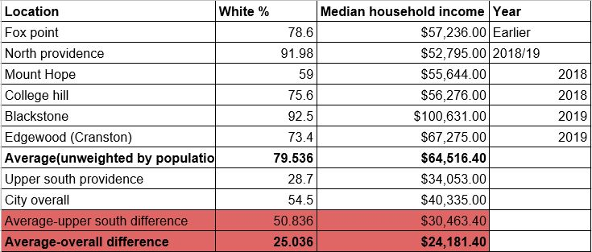

Moreover, using Providence Water’s public data, we can plot the proportion of households with the lead dimension of need against household income, as seen below.

Based on the stylized “U” shape of this graph, recent water main repairs seem to have settled in the middle-to-high income center, where lead-based need is lower. A full understanding of how and why Providence Water chooses to repair certain neighborhoods over others is limited by the lack of publicly-available data or information on the topic. Future research into Providence Water’s decision-making process for repairs is needed.

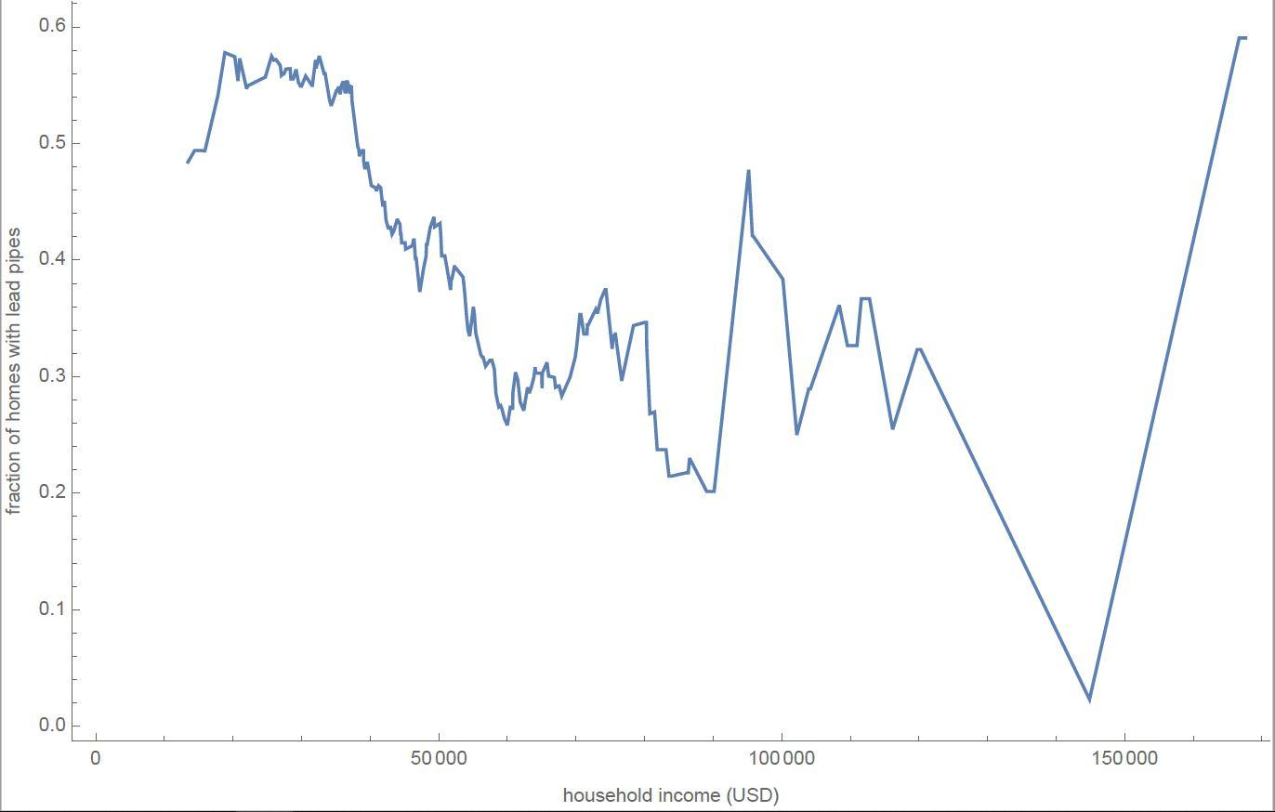

1. https://www.ecori.org/public-safety/2018/8/31/latest-biannual-test-finds-lead-in-providence-water
2. https://www.provwater.com/water_quality/lead-center
3. <https://www.cdc.gov/mmwR/preview/mmwrhtml/su6104a1.htm>
4. <https://www.who.int/news-room/fact-sheets/detail/lead-poisoning-and-health>
5. <https://www.cdc.gov/mmwR/preview/mmwrhtml/su6104a1.htm>
6. <https://www.who.int/news-room/fact-sheets/detail/lead-poisoning-and-health>
7. <https://www.atsdr.cdc.gov/csem/csem.asp?csem=34&po=8>
8. <https://ephtracking.cdc.gov/showChildhoodLeadPoisoning>
9. <https://www.ncbi.nlm.nih.gov/pmc/articles/PMC2717145/>
10. <https://www.brookings.edu/blog/up-front/2017/06/01/new-evidence-that-lead-exposure-increases-crime/>
11. <https://www.ncbi.nlm.nih.gov/pmc/articles/PMC4387706/>
12. <https://www.sciencedirect.com/science/article/abs/pii/S0014498316300109>
13. <https://www.ncbi.nlm.nih.gov/pmc/articles/PMC2717145/>
14. <https://www.epa.gov/lead/lead-test-kits>
15. <https://www.epa.gov/ground-water-and-drinking-water/basic-information-about-lead-drinking-water#health>
16. <http://www.provwater.com/node/853>
17. <https://www.youtube.com/watch?v=ijXHh0vY1ag>
18. <https://south-staffs-water.co.uk/help-and-advice/read/how-do-i-know-if-i-have-lead-pipes-200100000002814>
19. <https://www.provwater.com/loan>
20. <https://www.ewg.org/enviroblog/2016/02/how-filter-lead-your-tap-water>
21. <https://www.canr.msu.edu/news/water_filters_and_lead>
22. <http://health.ri.gov/healthrisks/poisoning/lead/for/landlords/>
23. <http://www.health.ri.gov/healthrisks/poisoning/lead/for/tenants>
24. <https://www.cdc.gov/nceh/lead/tips.htm>
25. [https://www.epa.gov/sites/production/files/2014-02/documents/lead_in_your_home_brochure_land_b_w_508_easy_print_0.pdf](https://www.epa.gov/sites/production/files/2014-02/documents/lead_in_you_home_brochure_land_b_w_508_easy_print_0.pdf)
26. <http://ohcd.ri.gov/consumer/>
27. http://www.rils.org/
28. http://www.richr.ri.gov/filecharge/iq.php/php
29. <https://www.ecori.org/public-safety/2018/8/31/latest-biannual-test-finds-lead-in-providence-water>
30. <https://www.cdc.gov/nceh/lead/tips/water.htm>
31. Sec. 2-18.3.
32. Sec. 13-54.
33. Sec. 10-32.
34. S 3098
35. [R.I.G.L. § 42.128.1-8](http://webserver.rilin.state.ri.us/Statutes/TITLE42/42-128.1/42-128.1-8.HTM)
36. [R.I.G.L. § 42.128.1-10](http://webserver.rilin.state.ri.us/Statutes/TITLE42/42-128.1/42-128.1-10.HTM)
37. R.I.G.L. § 23-24.7-2
38. R.I.G.L.§ 42-55-27
39. R.I.G.L.§ 23-1-5.3
40. <https://www.cdc.gov/mmwR/preview/mmwrhtml/su6104a1.htm>
41. R.I.G.L. § 5-20.8-2
42. <https://www.edf.org/sites/default/files/content/LSL-State-Disclosure-Report-Update0319.pdf>
43. http://www.ripuc.org/eventsactions/docket/4406-PWSB-Presentation_10-7-13.pdf
44. <https://journals.plos.org/plosmedicine/article?id=10.1371/journal.pmed.0050101>
45. <https://www.ncbi.nlm.nih.gov/pmc/articles/PMC2866705/>
46. As told to us by Carissa Richard of Providence Water (04/12/19)
47. <https://static1.squarespace.com/static/546d61b5e4b049f0b10b95c5/t/599c8eb1f14aa1f931306e15/1503432420273/20-Year+Infrastructure+Replacement+Plan+2016-2035+-+Final+KT1.pdf>
48. $500,000 per year for 5 years divided by total allocation for 5 years, which is $168,289,300
49. <https://www.epa.gov/newsreleases/epa-awards-more-21-million-rhode-island-support-local-clean-water-projects-across-1>
50. <https://www.wpri.com/news/local-news/providence/providence-water-offering-loans-to-replace-lead-plumbing/1818255069>
51. <http://www.provwater.com/node/854>
52. <https://www.wpri.com/news/local-news/providence/providence-officials-introduce-lead-free-water-program/1179158748>